Rudra Modi

ruraina@microsoft.com

Abstract

Learn how to leverage the Dynamics 365 Health Accelerator integration with devices through this Setup Guide

Dynamics 365   
health accelerator   
IOT INTEGRATION

Microsoft Corporation

Contents

No table of contents entries found.

# Overview

This document outlines the setup guide for enabling device connectivity in Health scenarios built on top of the Healthcare Accelerator. Once complete, you can use the Azure IOT Central app for managing devices and leverage data from these devices to take critical decisions. For sample purposes, we are using simulation to send device data to Azure IOT hub. There are rules configured to send alerts to a CDS instance when device readings cross threshold values.

If you are looking for information on the health accelerator such as the API reference or examples for extending the model, please look [here](https://community.dynamics.com/365/b/healthaccelerator/dashboard).

# Components of the Accelerator

The accelerator consists of several components as shown below. The scope of this document is to outline how MS Teams can be used in context of the HealthCare Accelerator.

* Entity Model: extensions to the Microsoft Common Data Model
* UCI App: Customer Engagement sample UCI App
* Legacy App: Customer Engagement Legacy App
* Office: How MS Teams can be used in context of the Healthcare Accelerator
* Power BI: Power BI extensions and samples
* Portals: Patient experience thru Dynamics Portals
* *IOT: Current guide outlines IOT scenarios and samples
* *AI / Azure: We are working on AI / Azure extensions and samples

# Pre-requisites

* Required Roles - Office Global Administrator
* Licenses – Active Azure subscription required. Or you can try out a sample Azure IOT central app with the trial link [here](https://aka.ms/iotcentral)
* Supported devices – the current guide outlines steps to simulate devices for an E-E experience of device connectivity. Here is the list of supported real-time devices that can connect to Azure IOT Hub.

<https://catalog.azureiotsolutions.com/>

# Setup – Import customizations

## Import Customizations

Navigate to the github folder and import the ‘IOTCustomizations.zip’ solution into your organization. Publish customizations.

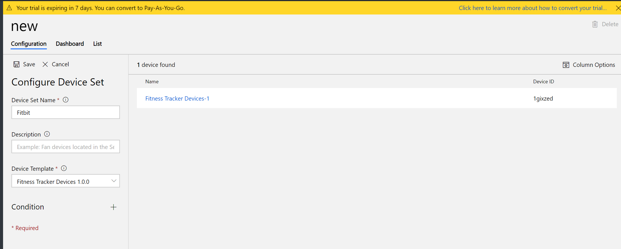

# Setup – Azure IOT Central App

## Setup Azure IOT Central app

* Using your tenant credentials, navigate to the [Azure Portal](https://portal.azure.com)
* If you have an active subscription, search for “Azure IOT central App”. Else, begin setup of IOT central app [here](https://aka.ms/iotcentral). Follow instructions as below.

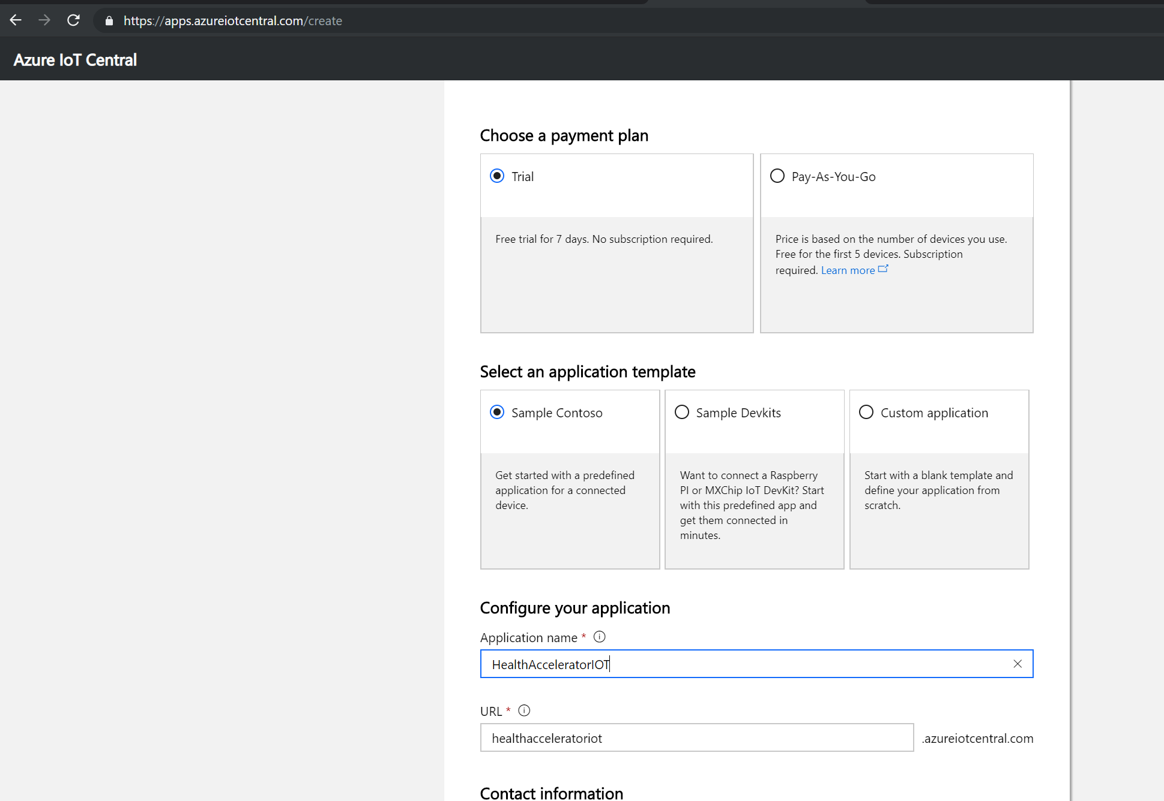

* Once the IOT central app is ready, you should be able to view it in the azure portal and navigate to the app link eg: [https://healthacceleratoriot.azureiotcentral.com](https://healthacceleratoriot.azureiotcentral.com/).
* On the IOT central app dashboard, go to ‘Device Templates’. Create a new Device Template. Call it ‘Fitness Tracker Devices’
* Since we are using simulation for devices, choose ‘Custom’ as template. Else choose whichever type of device you are configuring it for.

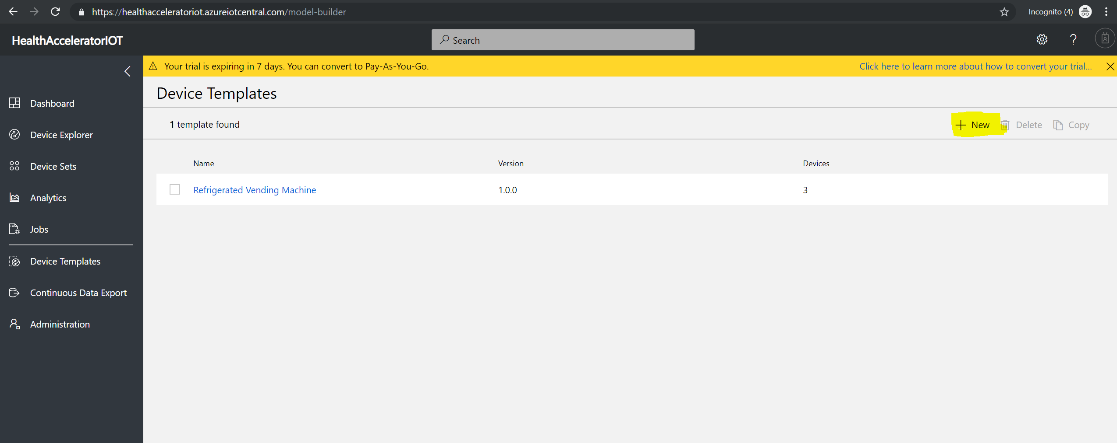

* Once the device template is created, create measurements for tracking the device as shown below.

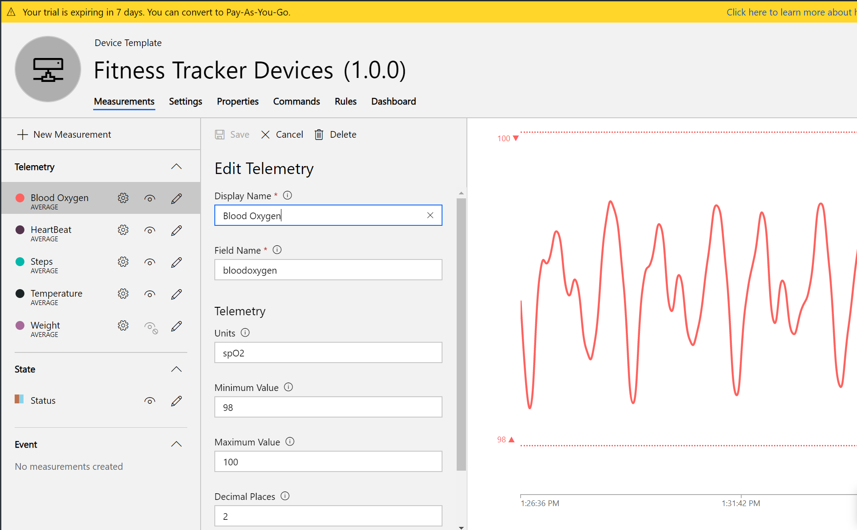

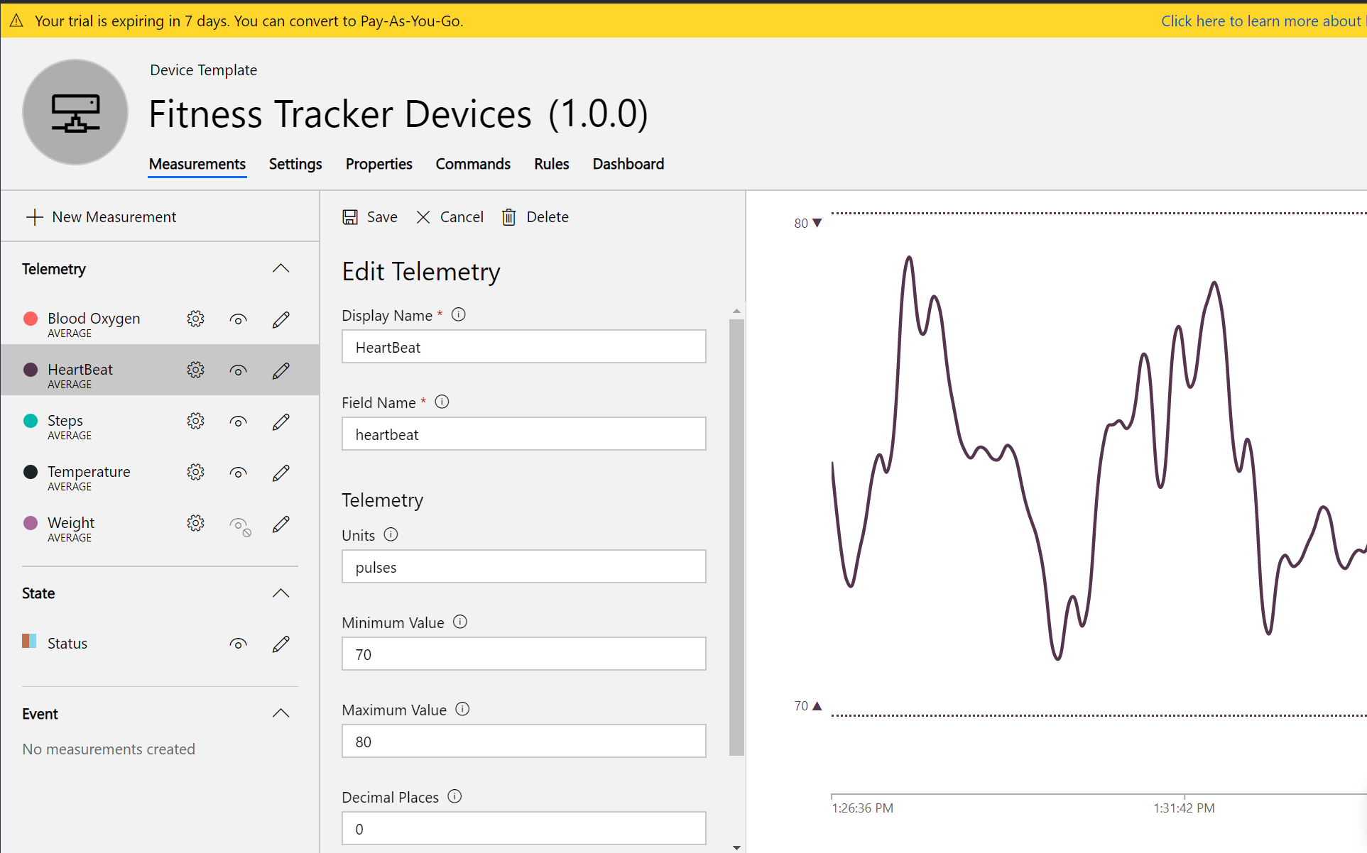

* Once the measurements are configured, here is how the dashboard will look like –

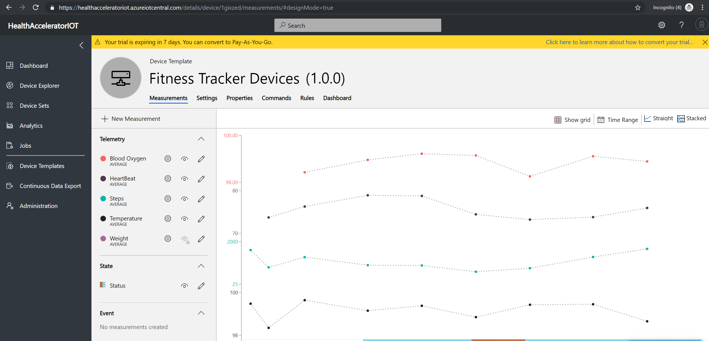

* Now that the measurements are defined, we can configure rules to monitor device data and trigger actions.
* Depending on your scenario, you can either choose to push all device data into a transactional CDS or just choose to take action in threshold scenarios.
* Click on the ‘Rules’ tab, and create a new rule. Define condition for a threshold such as ‘heartbeat greater than or equal to 120’. Set action as any of the below –
  + Email
  + Webhook
  + Azure Functions.

If you are following the trial IOT central app link, you can use any of the options above to create an action for the rule. Else, on a pay as you go subscription, you also have the option to trigger a Flow, Logic App, or Monitor Action Group.

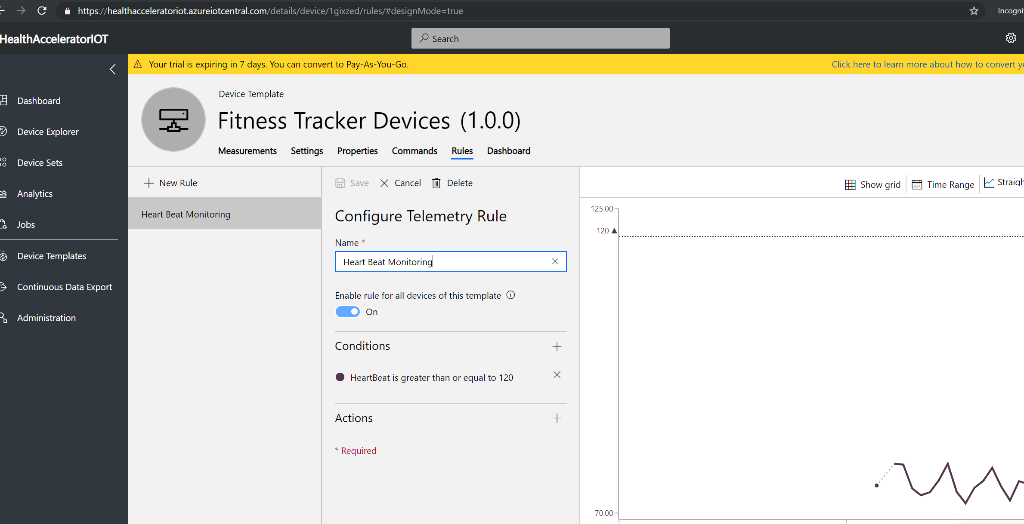

As an example, we will create a flow to push all device reading data to a transactional CDS.

* Configure the action to use ‘Microsoft flow’. Click on Import and upload the the flow called ‘Push device readings to CDS’ from the repo. Setup mappings for CDS Endpoint (i.e Dynamics org endpoint) and IOT central app and click on Import.

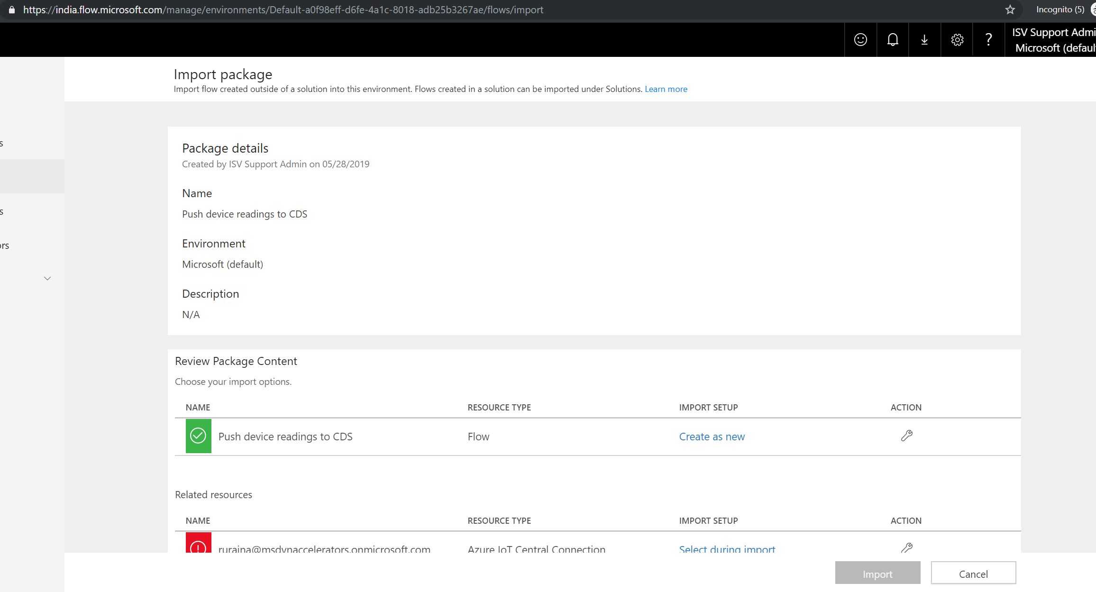

Once the flow is deployed, it should be creating a new ‘Device Data’ record when a Heartbeat threshold is met.

* With the Device template ready, add devices that will be sending messages to the IOT Hub. Navigate to ‘Device Sets’ on the IOT Central App dashboard and add new device.

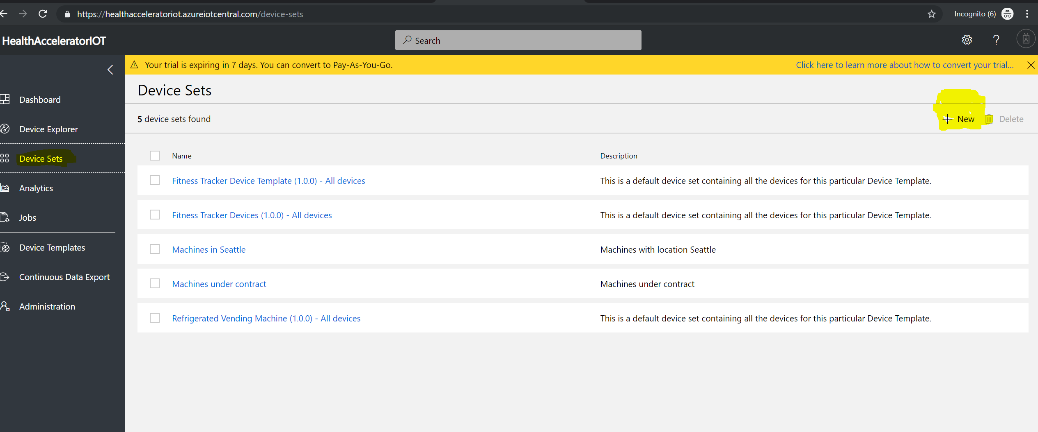



* You can add as many devices that follow the above device template.

## Configure Devices

When adding devices that follow a device template (either realtime or simulated) they need to be registered in the CDS org so that they are identified and tracked for device readings.

For each added device, note the ‘Device id’ and update it on the CDS org. This is important to trace back events/measurments from the device to the CDS org.

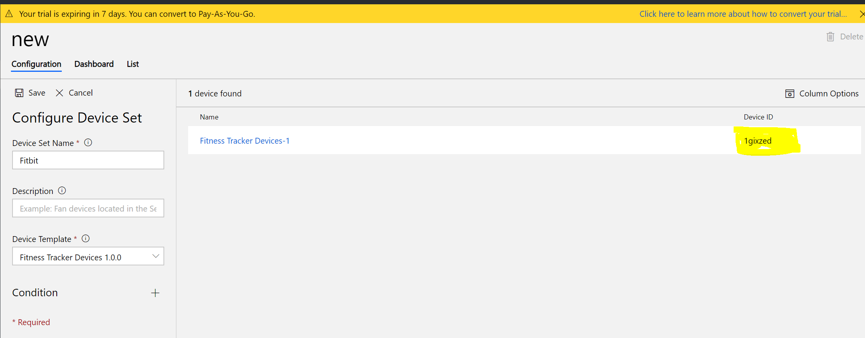

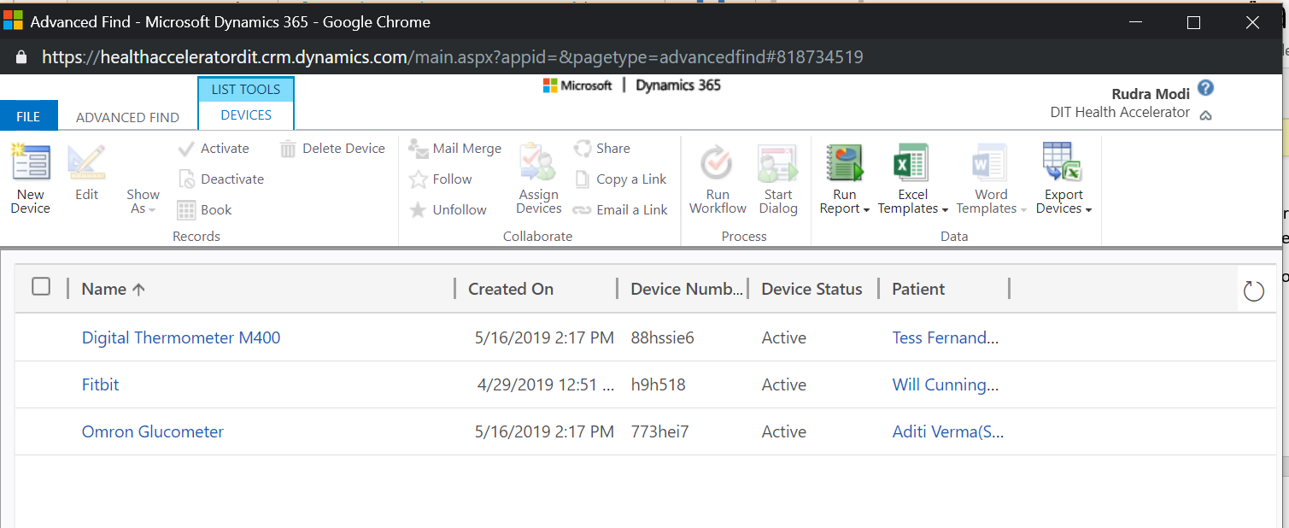

* Create a new device record in CDS org and update the same Device ID (as copied from the IOT central app). Also set the right patient record to indicate which patient the device is associated to.

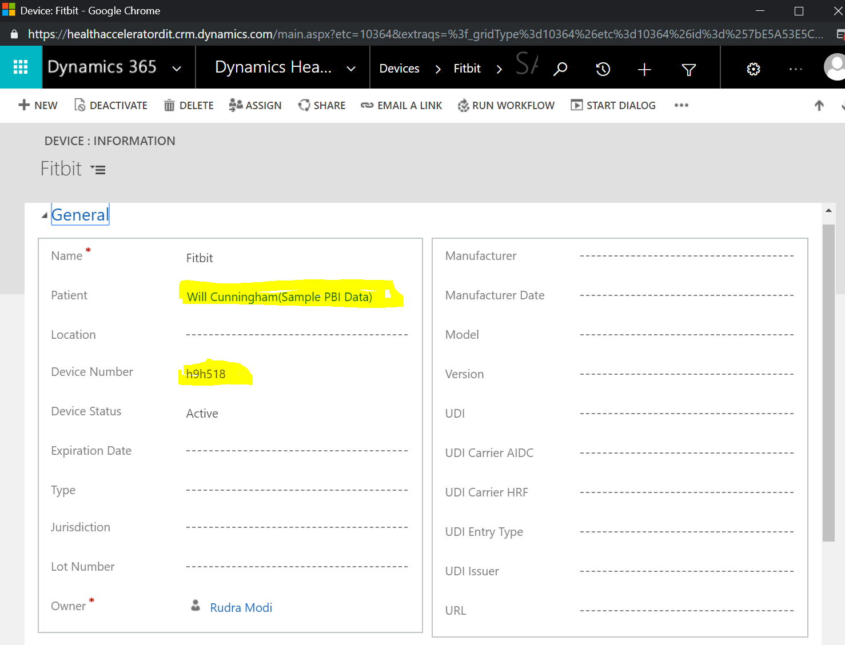

* Now wait for the simulations to trigger and send device readings. You can navigate to the CDS org and note the ‘Device Data’ records created thru the Flow.

